**OUTPUT SCREENS FOR THE PROJECT**

1. **The Home page of ERP system which contains dashboard**

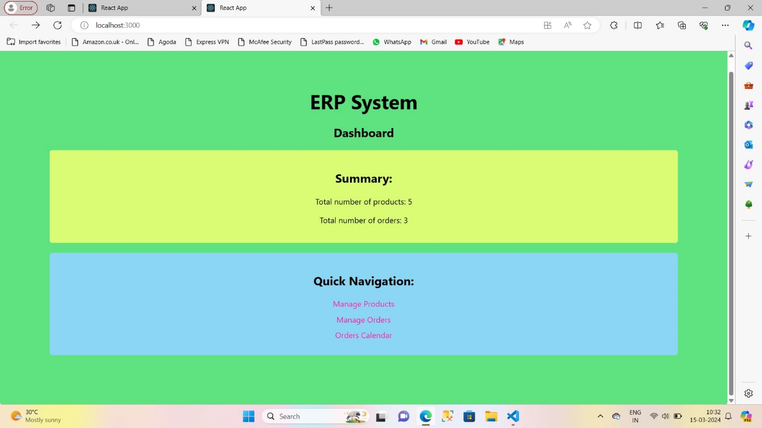

1. **The dashboard contains two sections:**

* Summary which contains the details of products and orders
* Quick Navigation which contains links to different pages

1. **The Manage products page:**

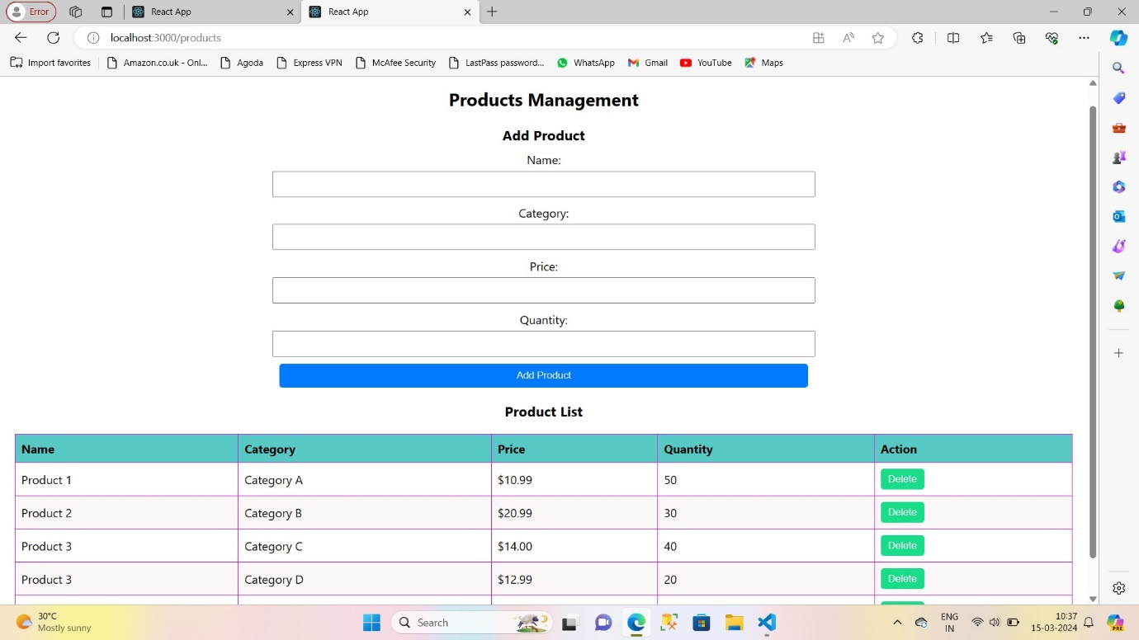

* **We can add , edit and delete the products**

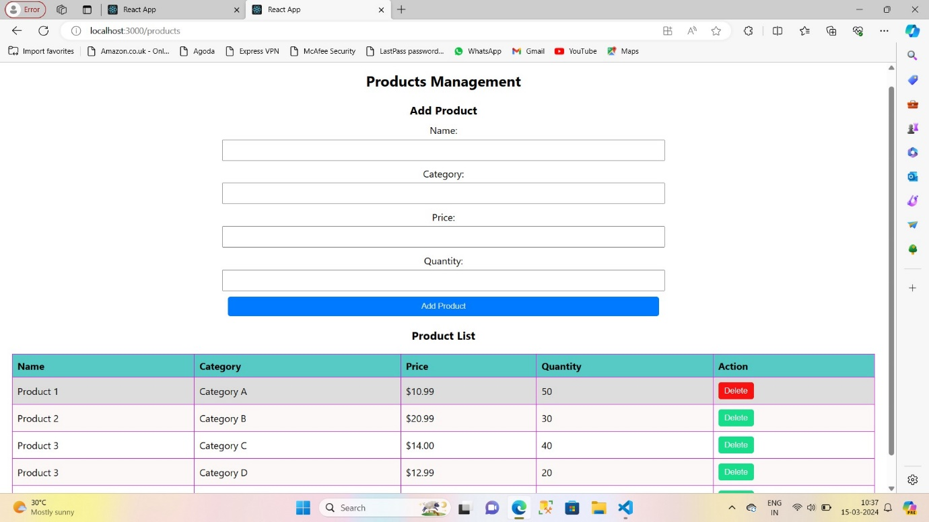

1. **The Manage orders page**

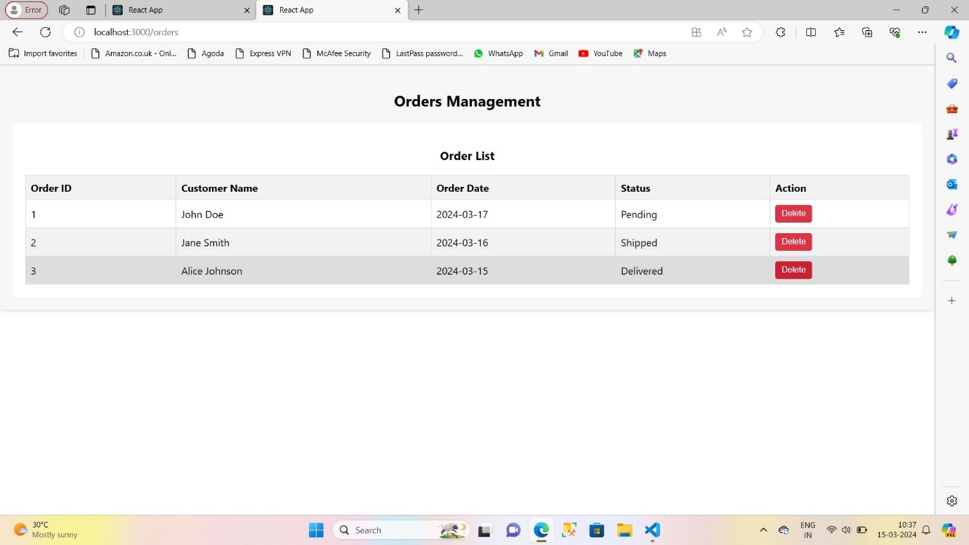

* **We can see the status of order and we can delete the order**



1. **OrdersCalendar**

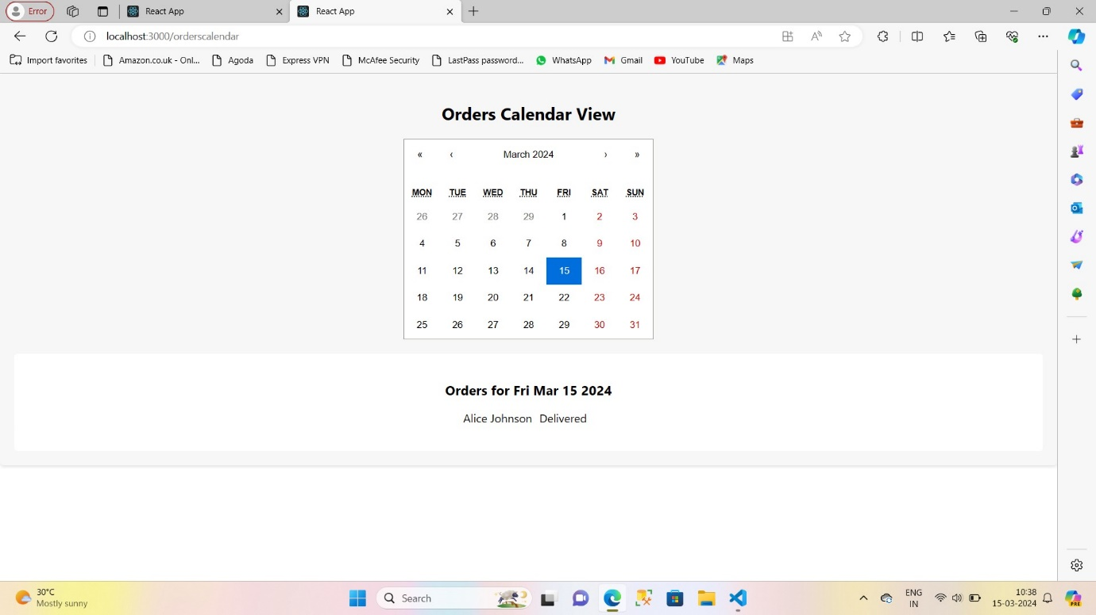

* We can see orders on a particular date

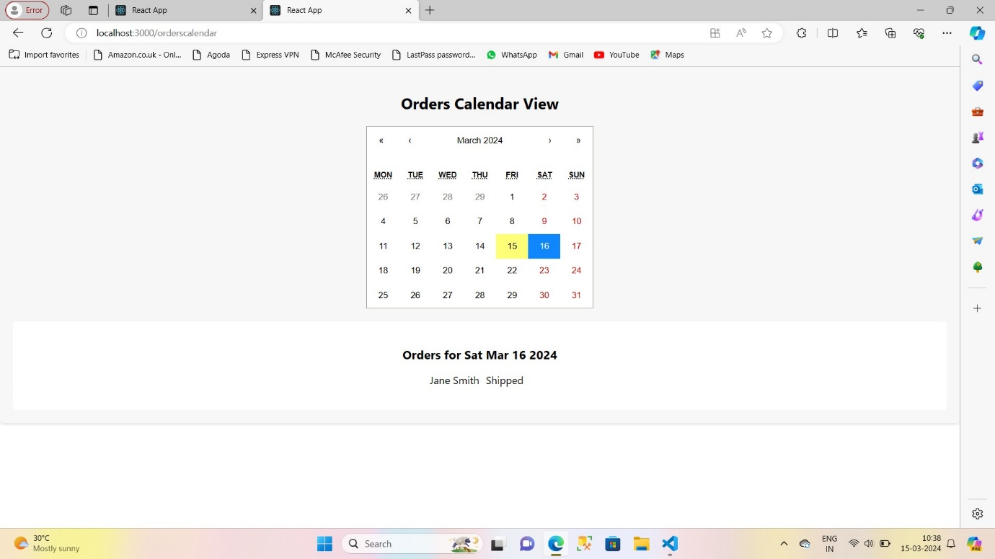

Video Explanation Link:

<https://drive.google.com/file/d/1qqLzRK6Cp7iGvBgXBvTW4jif3C0Hxgud/view?usp=sharing>